Module 05 Lab 01 Model Evaluation and Refinement Used Car Pricing Screenshot Evidence and Discussion
Reference label for this notebook: Lab1 (each heading below is numbered Lab1_1, Lab1_2 and so on).
This document collects the screenshots of Module 05 Lab 01, model evaluation and refinement on the used car dataset, and heads each one after the question or section it belongs to. The lab splits the data into training and testing sets, uses cross validation, studies overfitting with polynomials of different orders, and refines the model with Ridge regression and a grid search over alpha. Every screenshot is captioned with its file name.

Lab1_1. Section 0 Setup and the libraries used in the lab
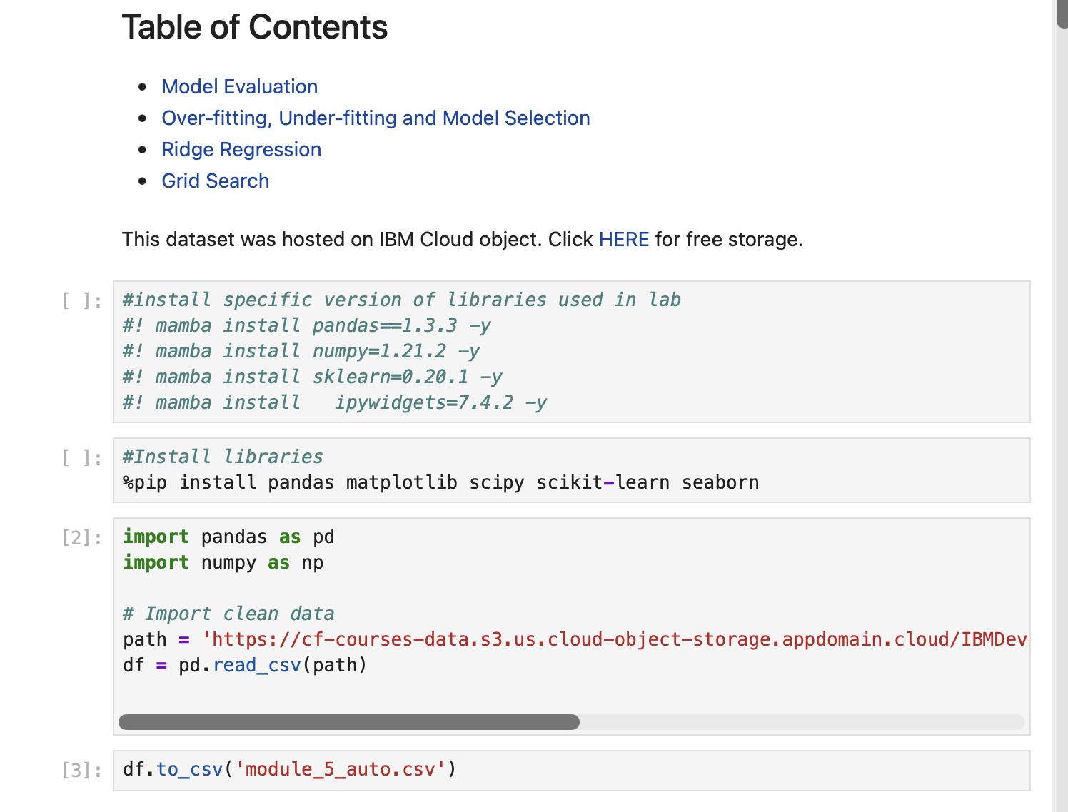
Screenshot file: 1_table_of_contents_import_install_code.png
The notebook starts by installing and importing the libraries for the whole lab (pandas, matplotlib, scipy, scikit-learn and seaborn) and lists the sections that follow.

Lab1_2. Section 0 Keeping only the numeric attributes
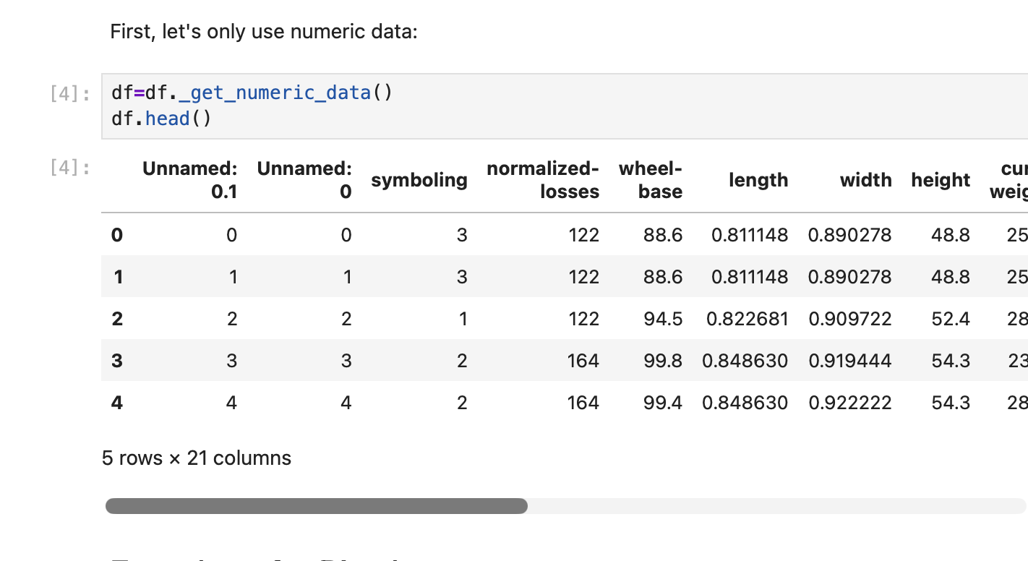
Screenshot file: 2_numeric_data_df_head.png
df._get_numeric_data() restricts the frame to the numerical columns and the head of the result is displayed, so the later models work on numbers only.

Lab1_3. Section 0 Defining the plotting helpers
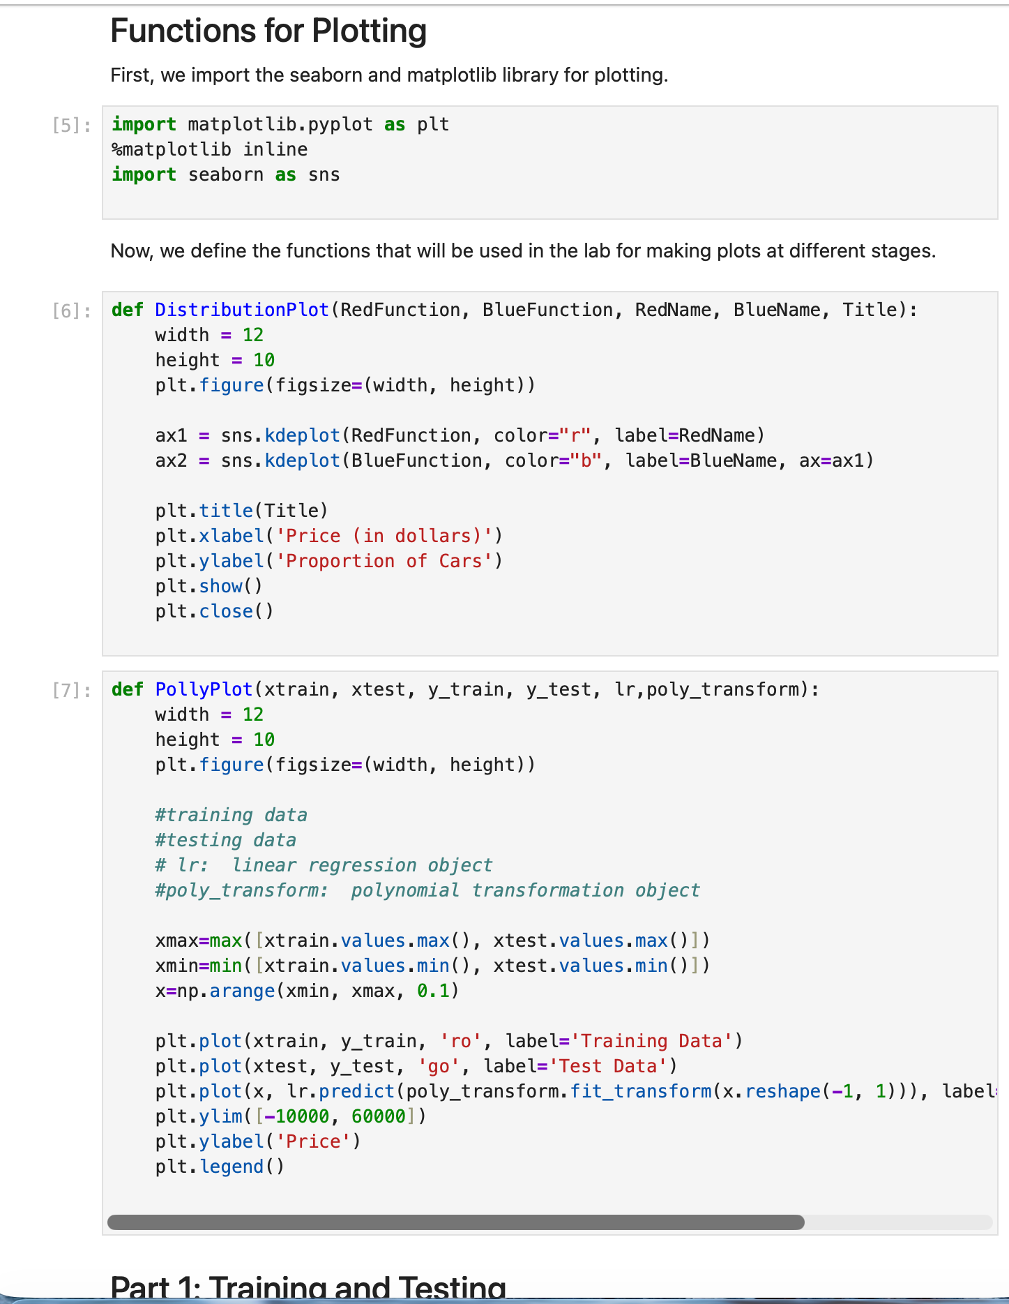
Screenshot file: 3_plot_functions_definition_code.png
The helper functions used later, which draw the polynomial fits and the distribution plots, are defined here so every section can call them.

Lab1_4. Part 1 Training and testing
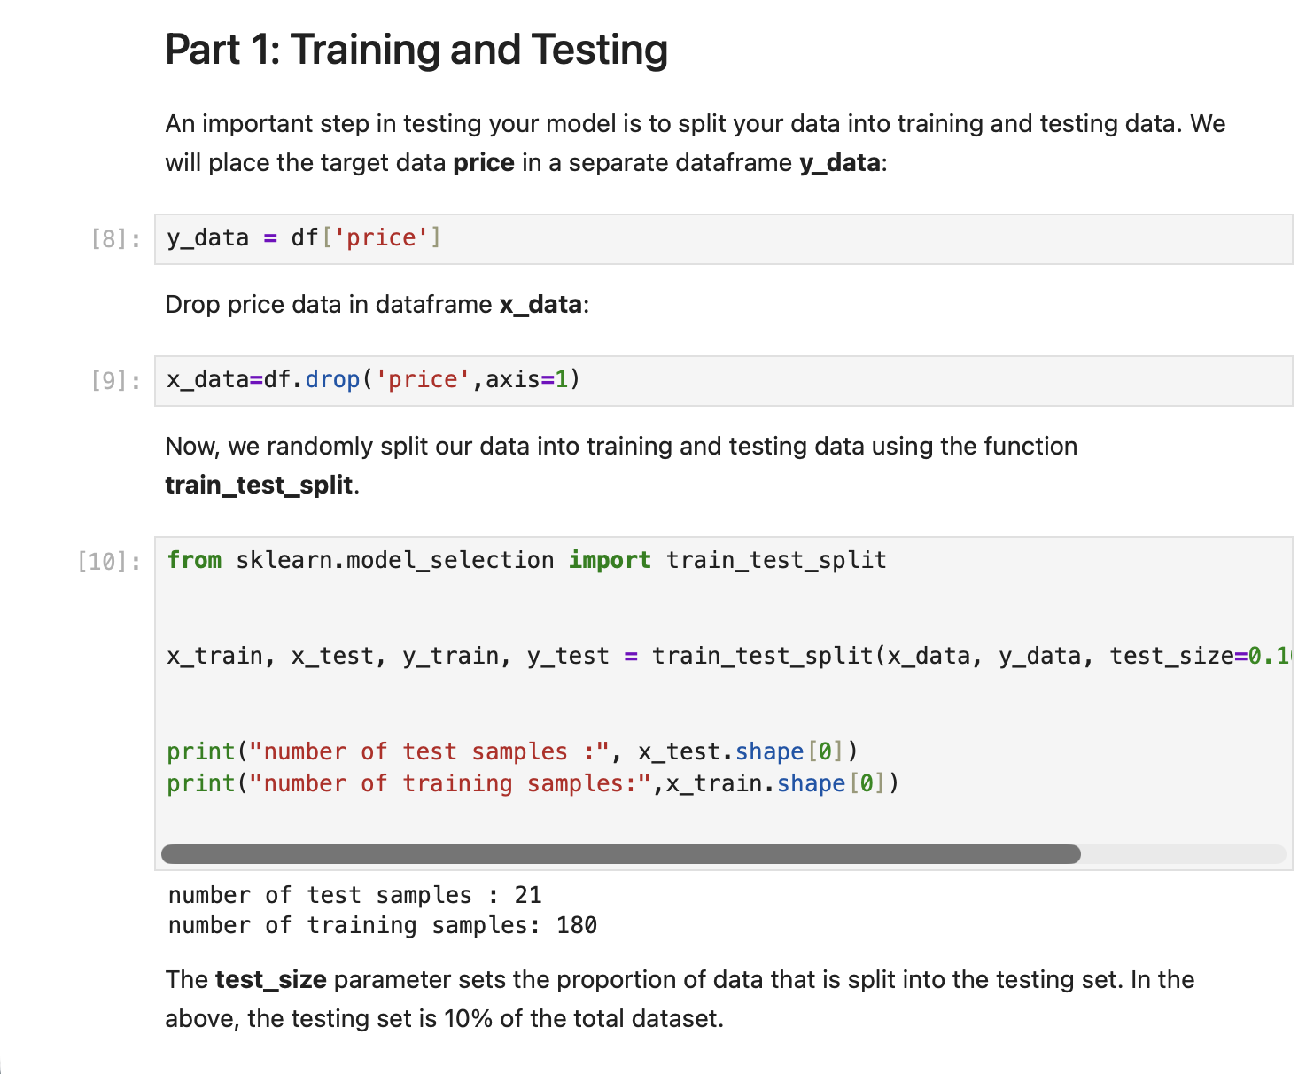
Screenshot file: 4_part1_train_test_split_code.png
The section explains why the data is split: the target price is separated from the features so the model can be measured on data it has not seen.

Lab1_5. Question 1 Splitting the data with train_test_split
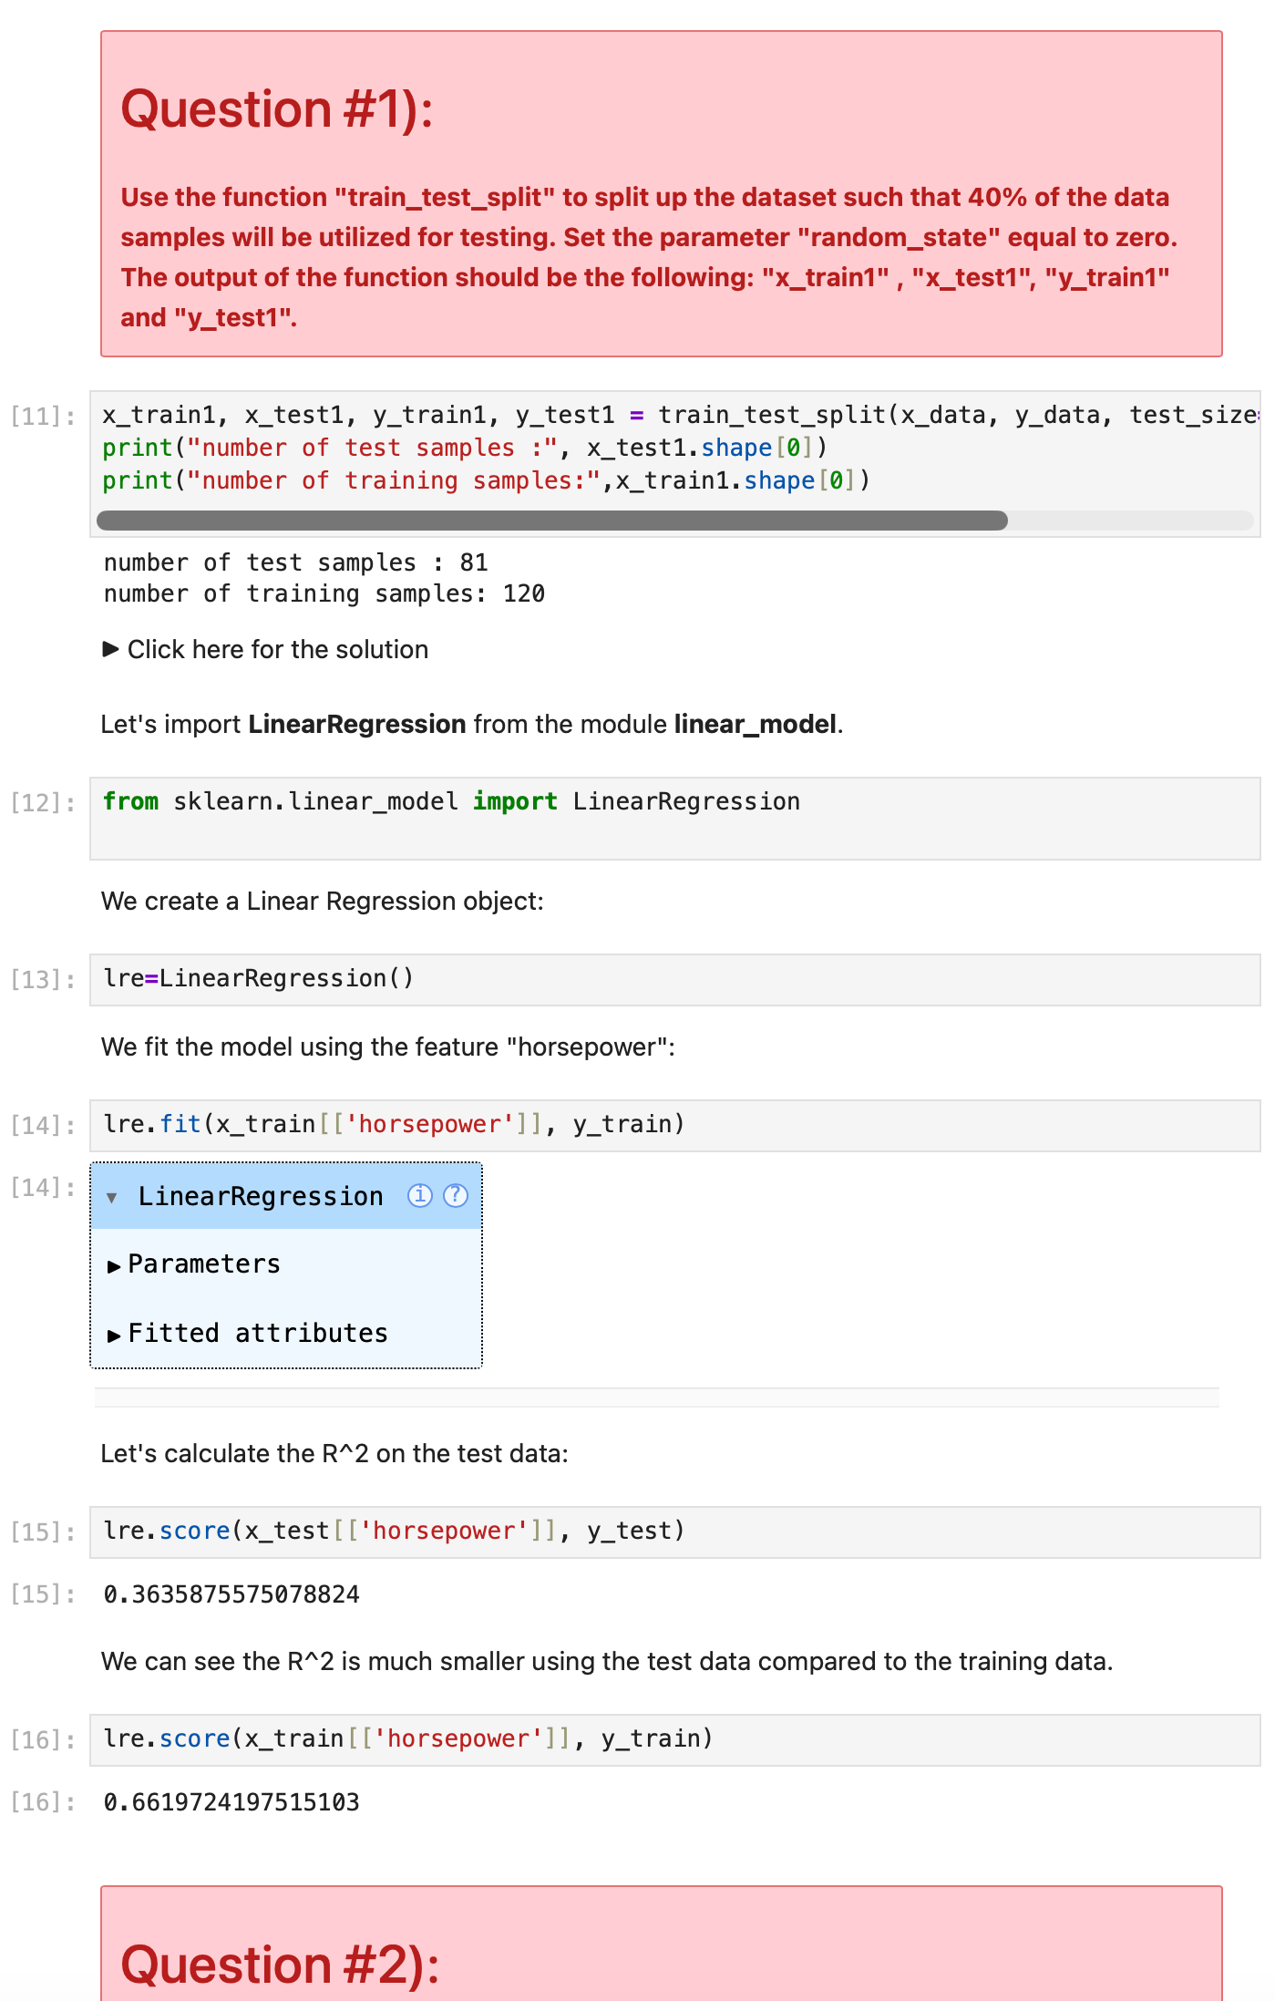
Screenshot file: 5_q1_split_linear_regression_code.png
train_test_split is called with test_size = 0.4 and random_state = 0, so 40 percent of the sales are reserved for testing.

Lab1_6. Question 2 R squared on the test data
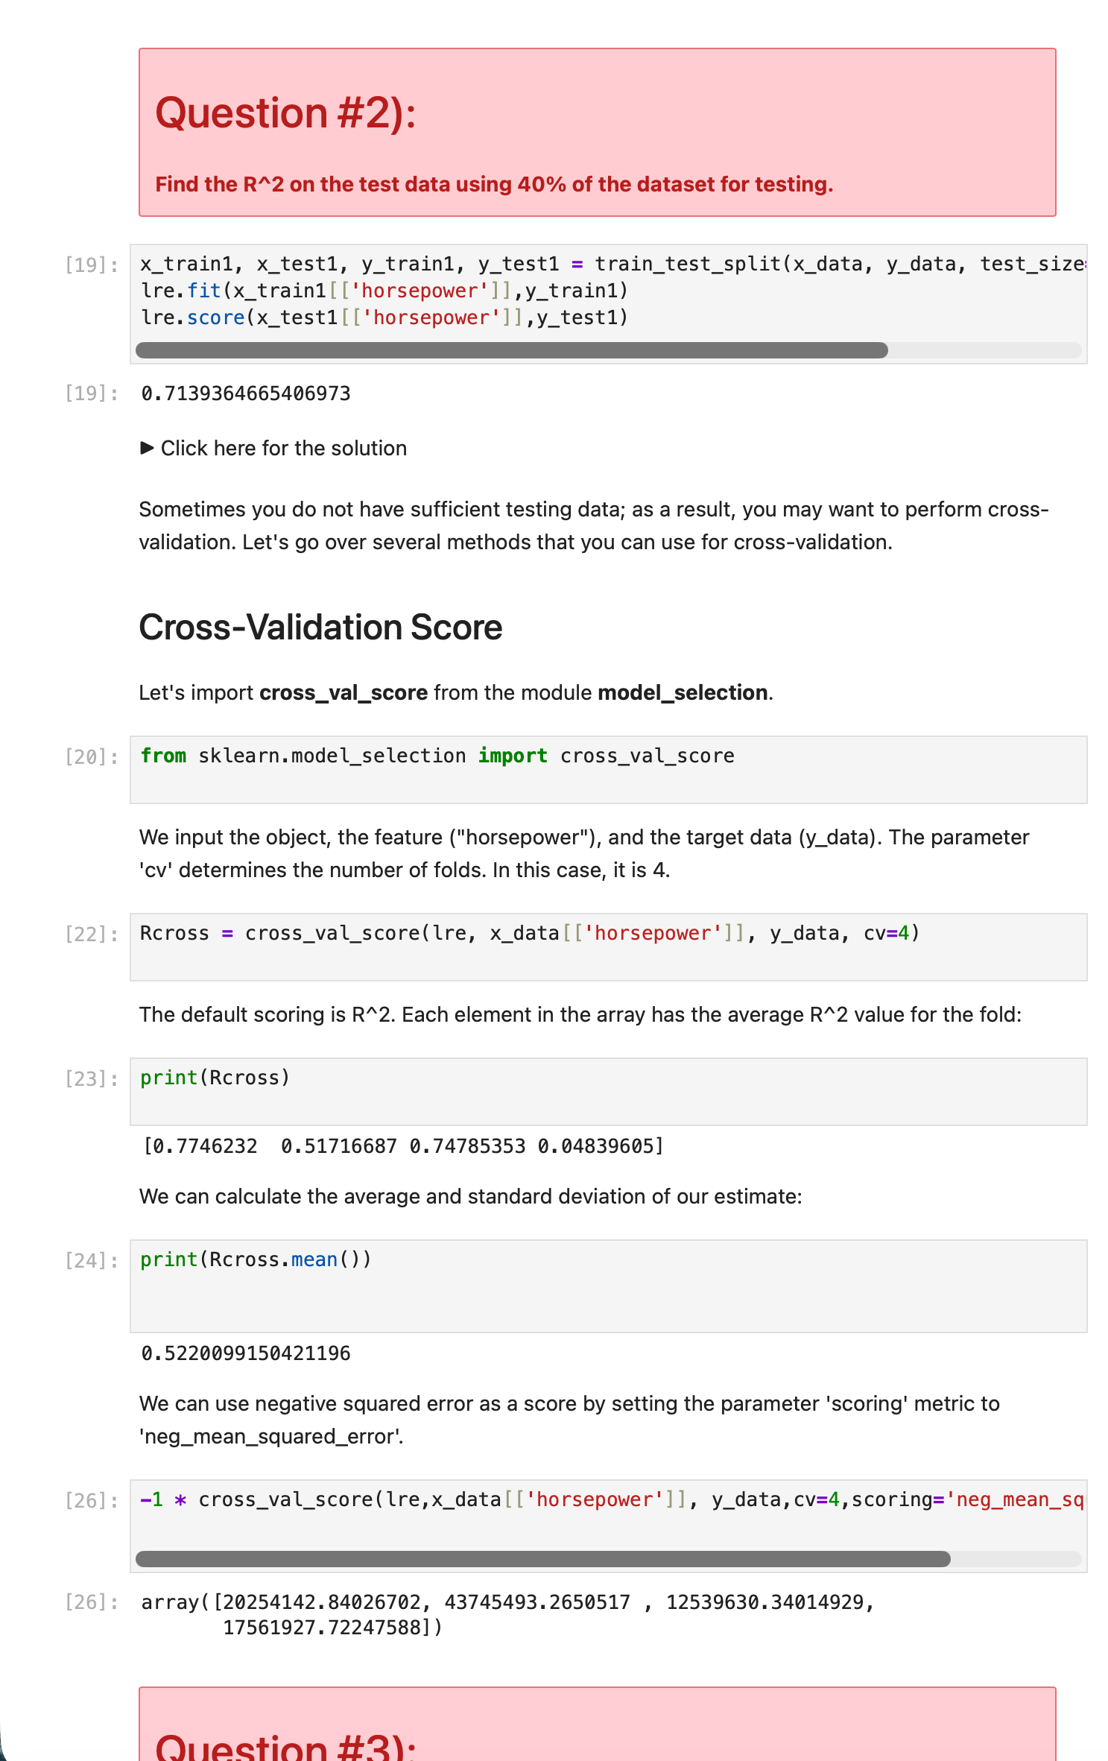
Screenshot file: 6_q2_cross_validation_code.png
The single feature model is fitted on the training split and scored on the test split, which gives the R squared requested by the question.

Lab1_7. Question 3 Cross validation with several folds
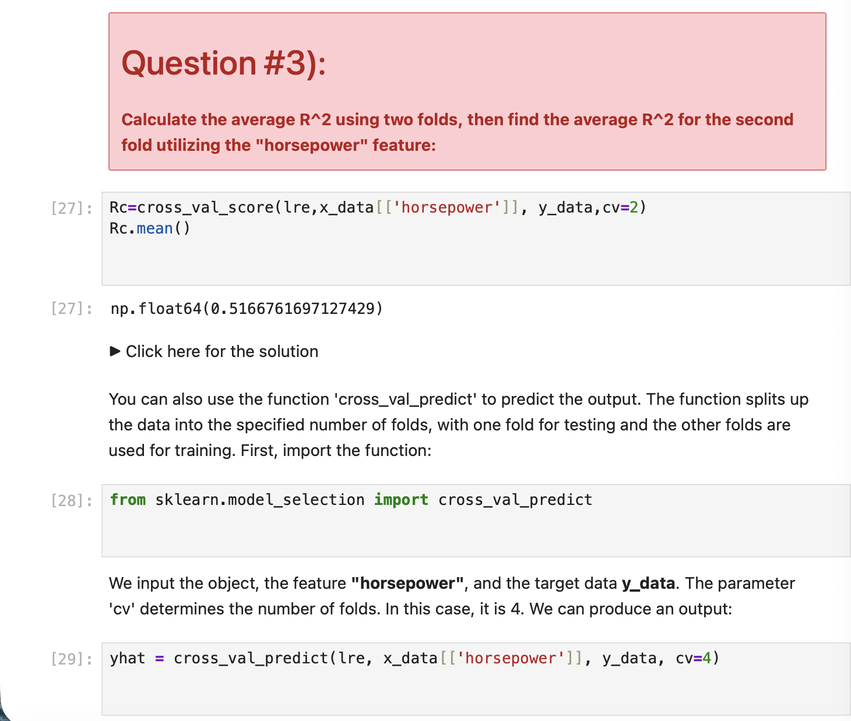
Screenshot file: 7_q3_cross_val_predict_code.png
cross_val_score and cross_val_predict are used to average the model performance over folds instead of relying on one split.

Lab1_8. Part 2 Overfitting, underfitting and model selection
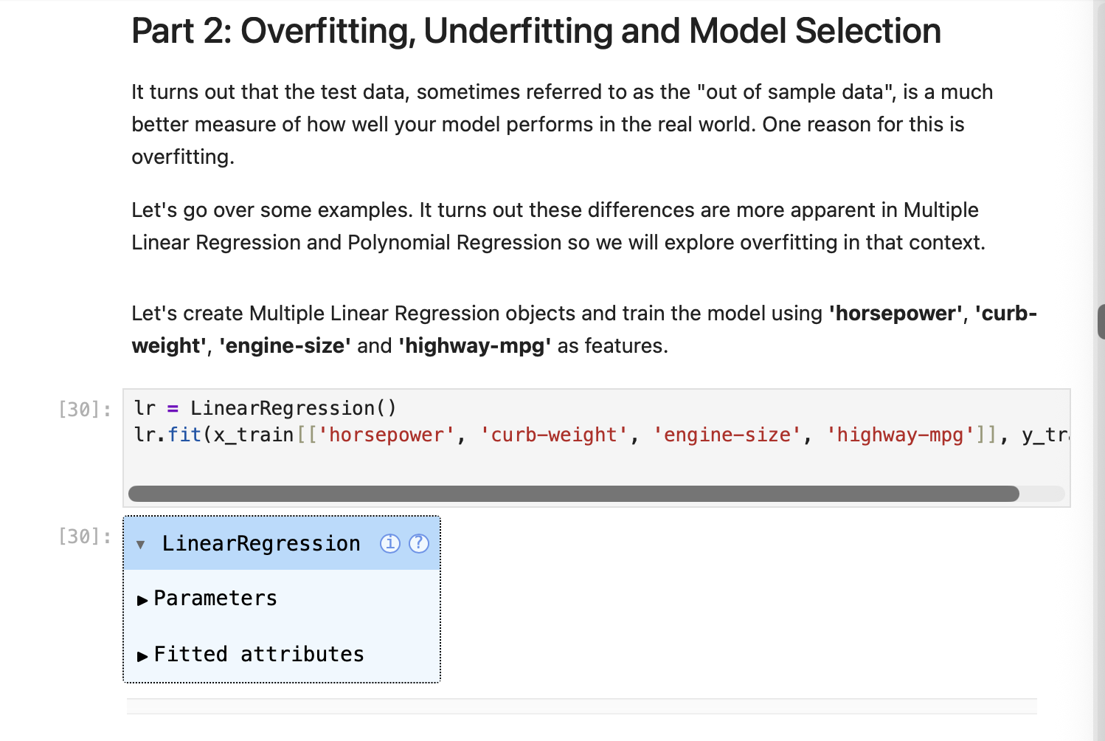
Screenshot file: 8_part2_multiple_linear_regression_code.png
The section introduces the difference between a model that generalises and one that fits the noise of the training data.

Lab1_9. Part 2 Predicting with the multiple regression
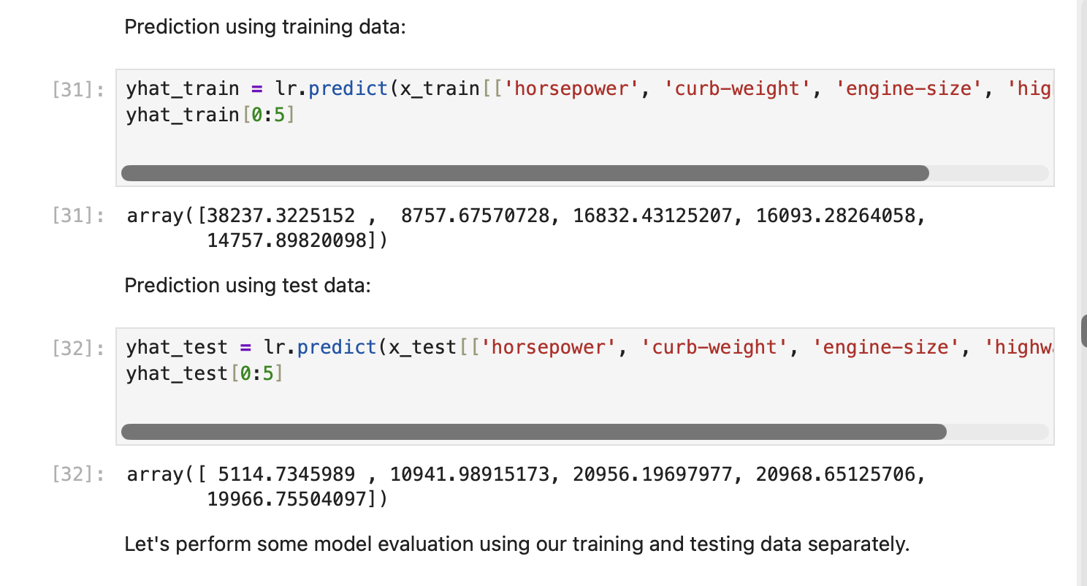
Screenshot file: 9_train_test_predict_code.png
The four feature model is fitted on the training data and used to predict the test set, which prepares the distribution comparison.

Lab1_10. Part 2 Distribution plot on the training data
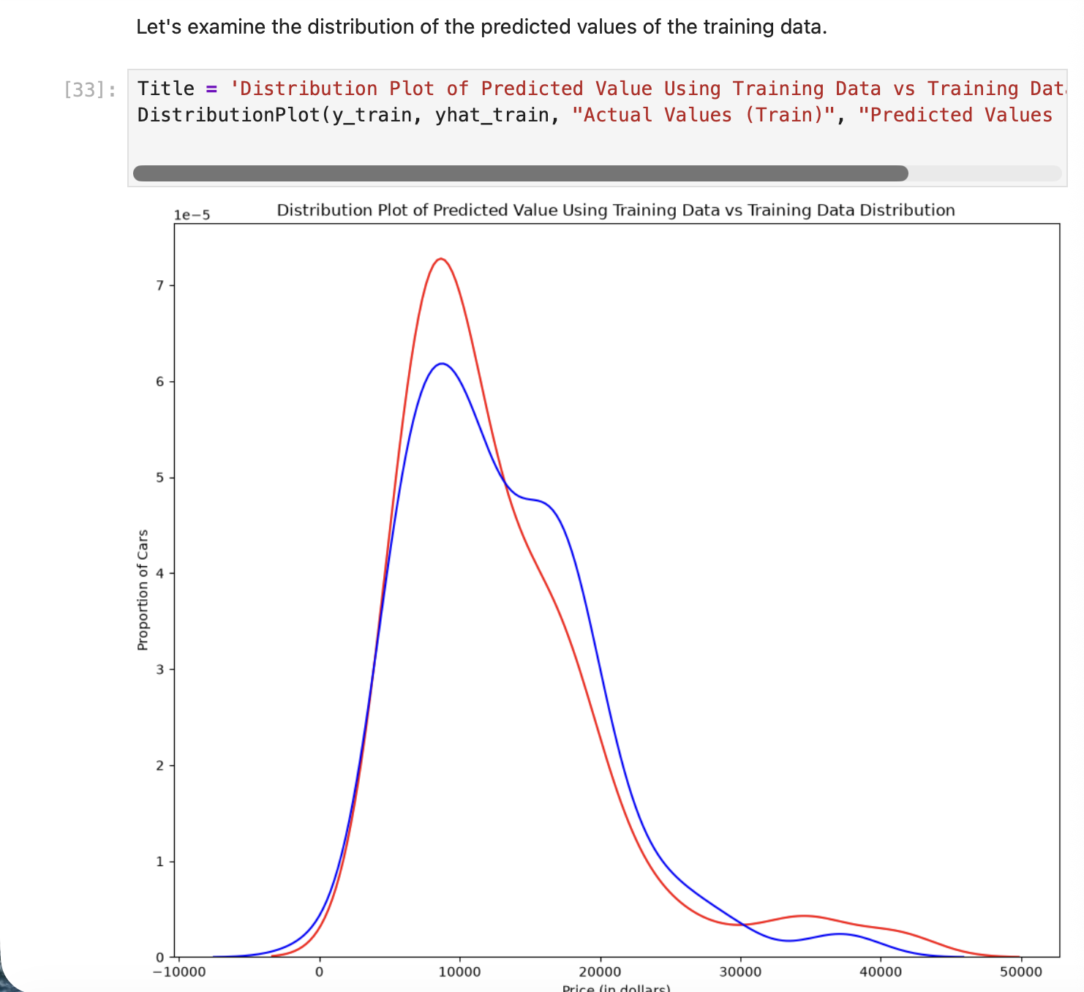
Screenshot file: 10_distribution_plot_train.png
The distribution of the predicted values is compared with the actual training prices using the distribution helper.

Lab1_11. Part 2 Distribution plot on the test data
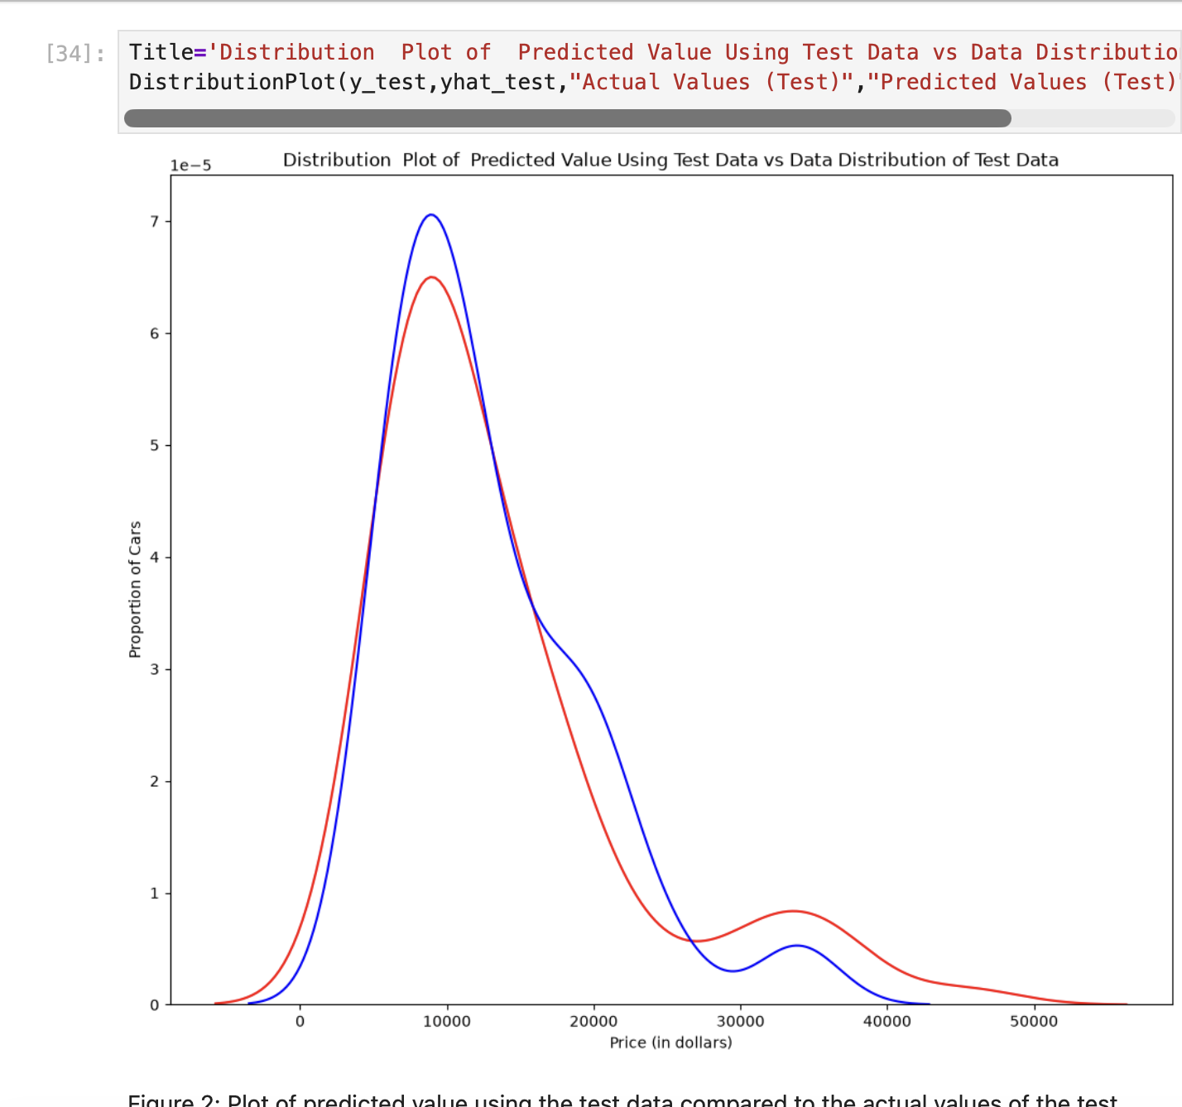
Screenshot file: 11_distribution_plot_test.png
The same comparison is repeated for the test split, which is the honest measure of how the model behaves on unseen data.

Lab1_12. Part 2 Overfitting with a fifth order polynomial
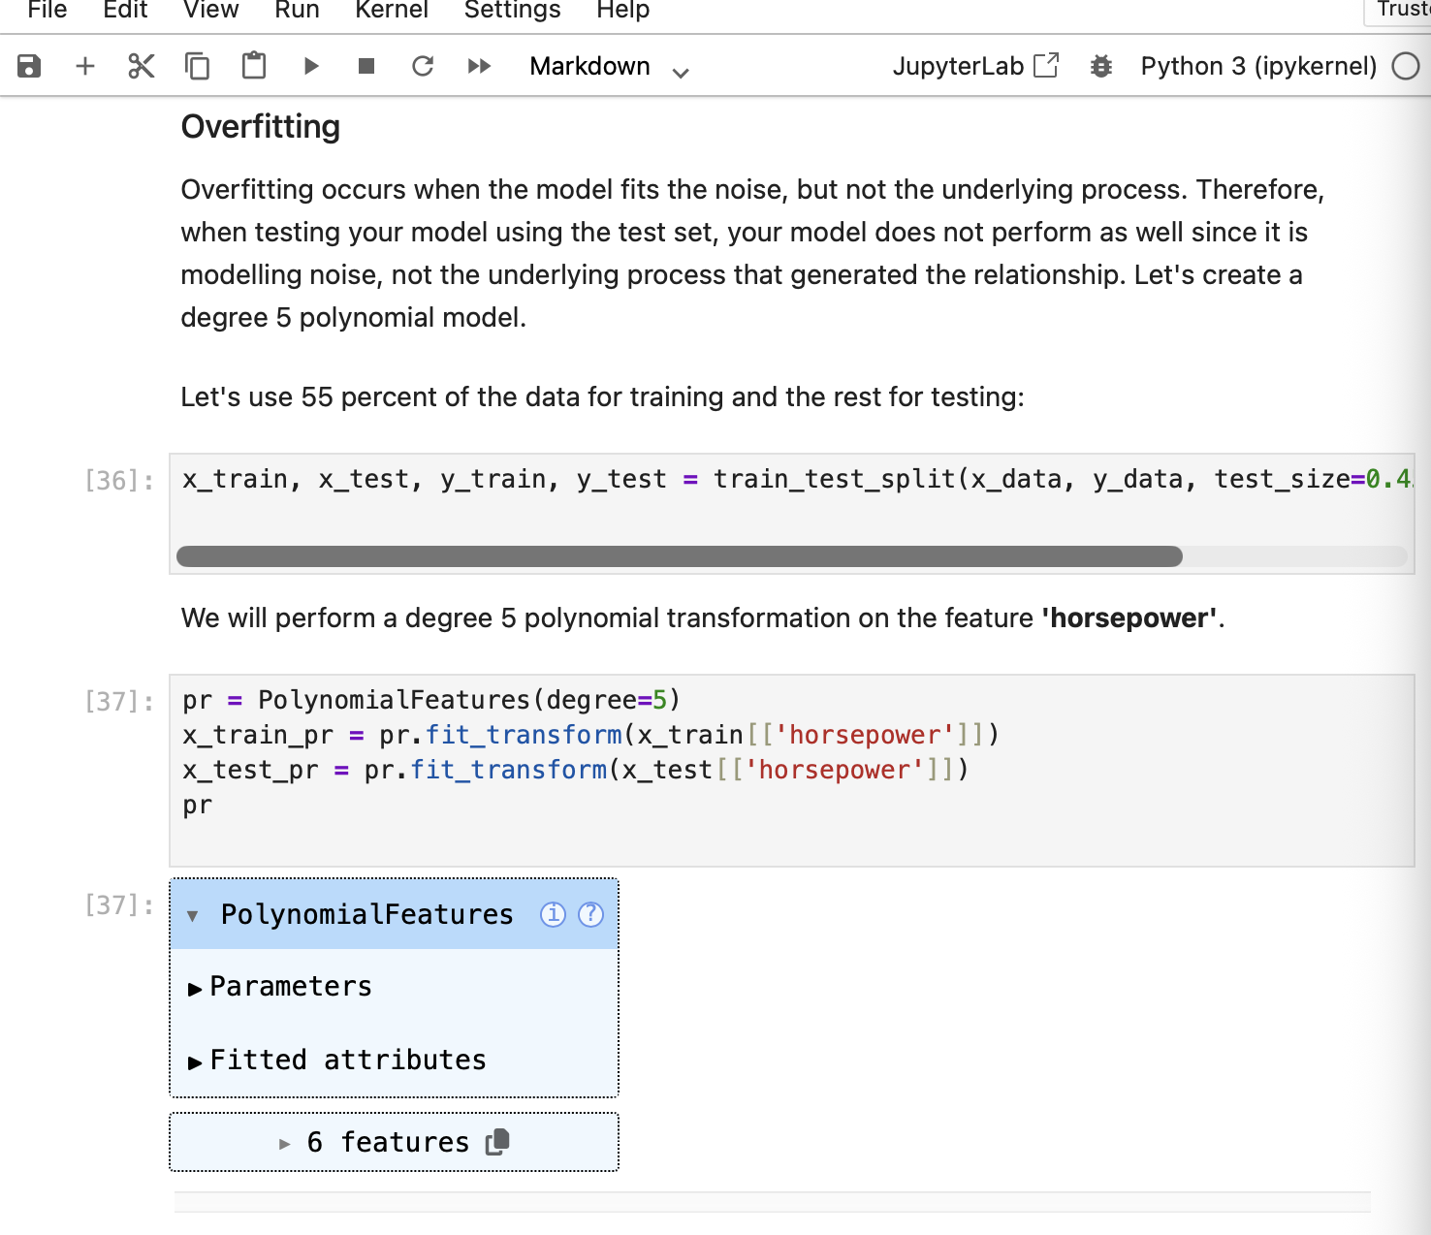
Screenshot file: 12_overfitting_poly5_code.png
The section and the code that follows show what happens when a very flexible polynomial is fitted to the training data.

Lab1_13. Part 2 Printing the predictions next to the true values
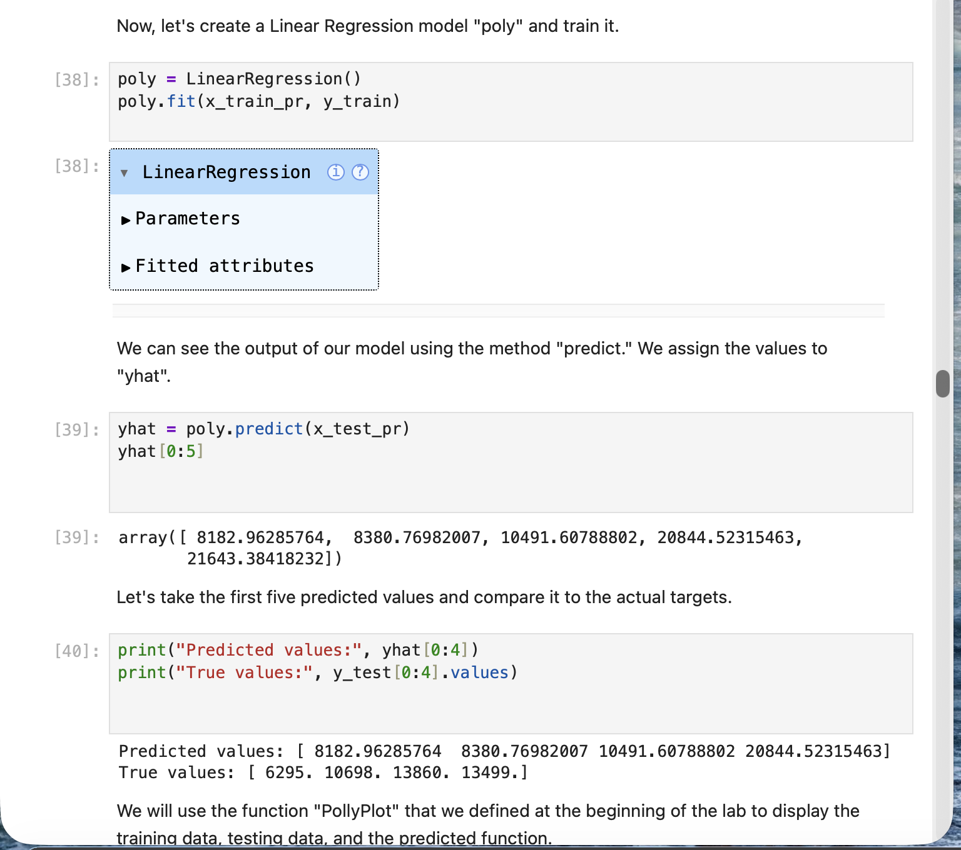
Screenshot file: 13_poly_model_train_predict_code.png
The predicted values and the true test values are printed side by side, which makes the size of the errors visible.

Lab1_14. Part 2 Figure 3: polynomial regression with training and test points
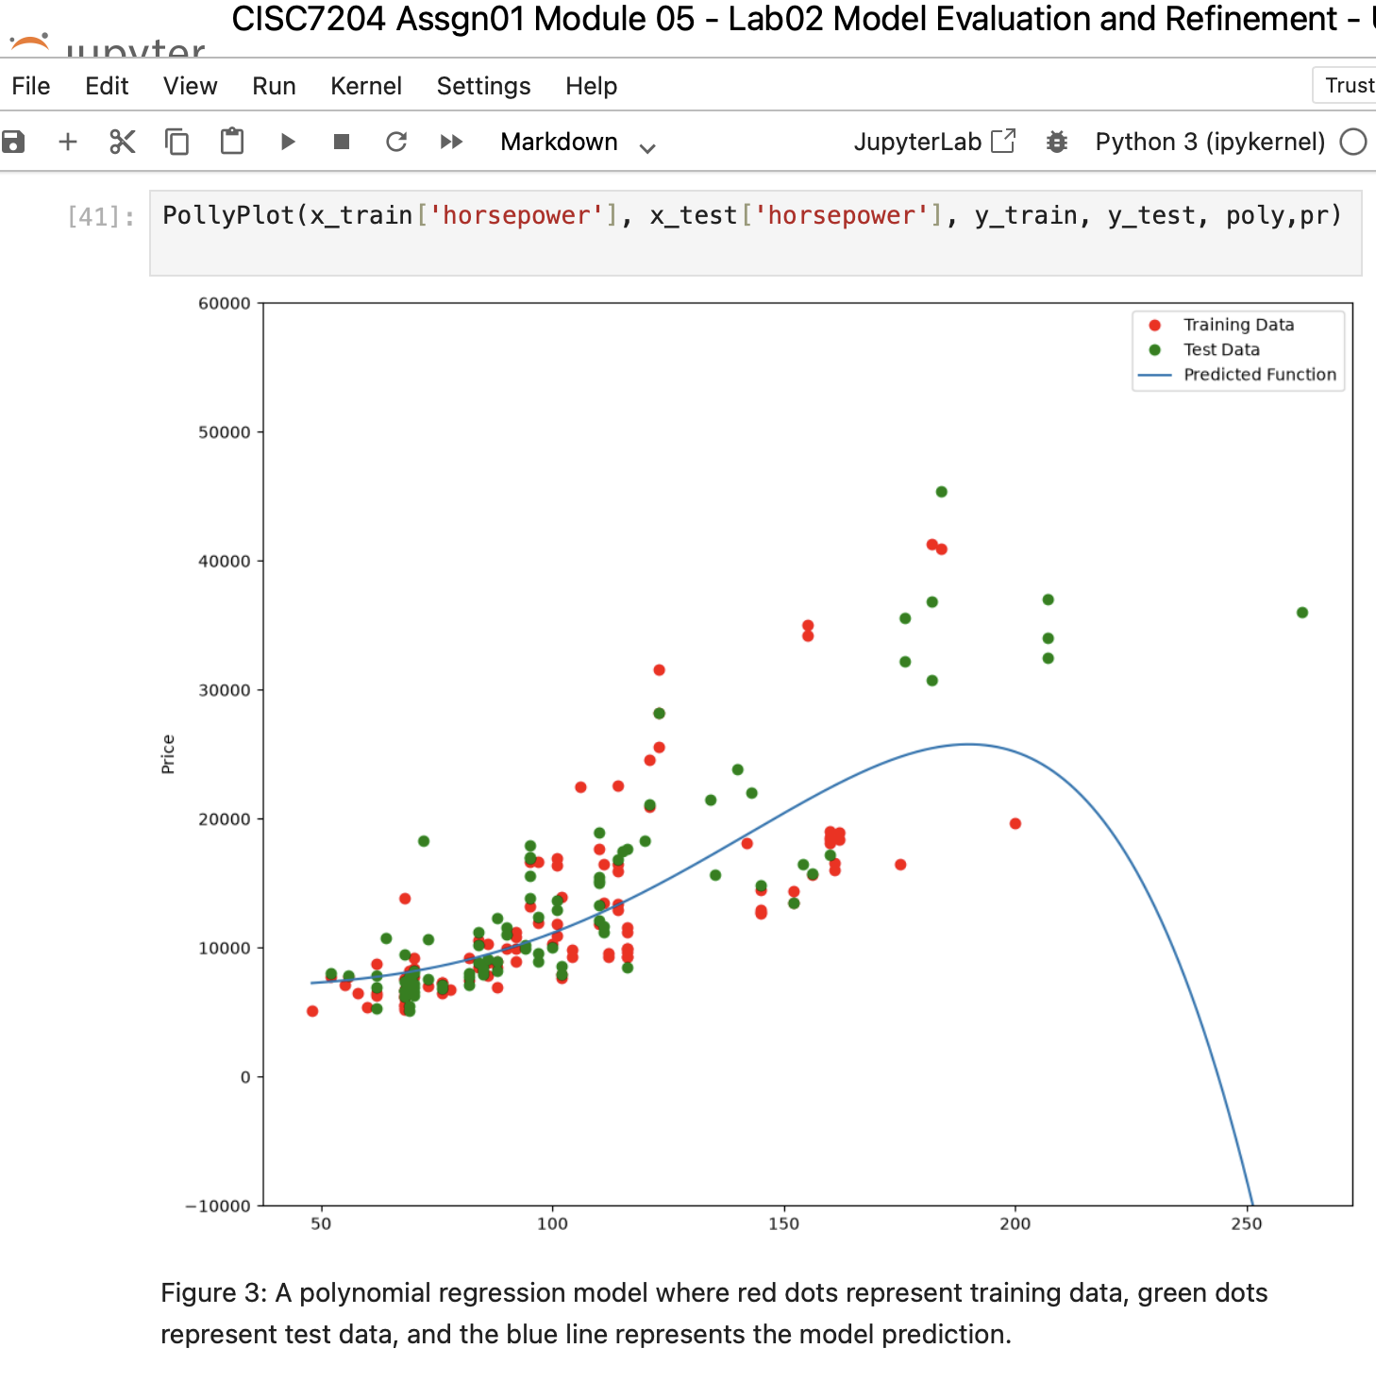
Screenshot file: 14_pollyplot_poly5_figure3.png
The figure shows the training points, the test points and the fifth order curve, the visual evidence of the overfitting discussed in the text.

Lab1_15. Part 2 R squared for different polynomial orders
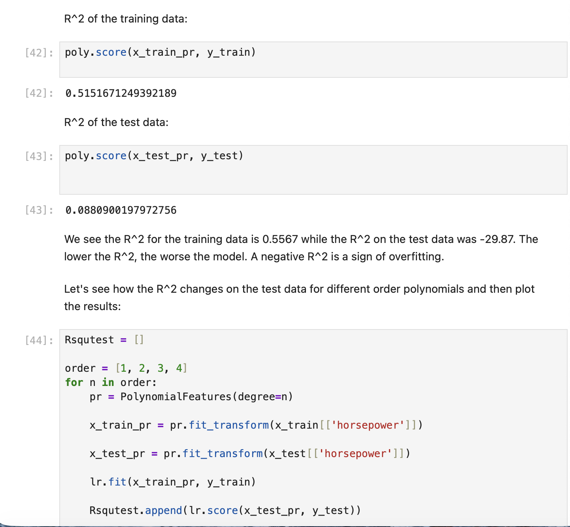
Screenshot file: 15_poly_different_order_r2_code.png
The R squared of the training and test sets is printed for the different orders; the training value of about 0.5567 against a large negative test value shows the overfit.

Lab1_16. Part 2 Plotting R squared against the polynomial order
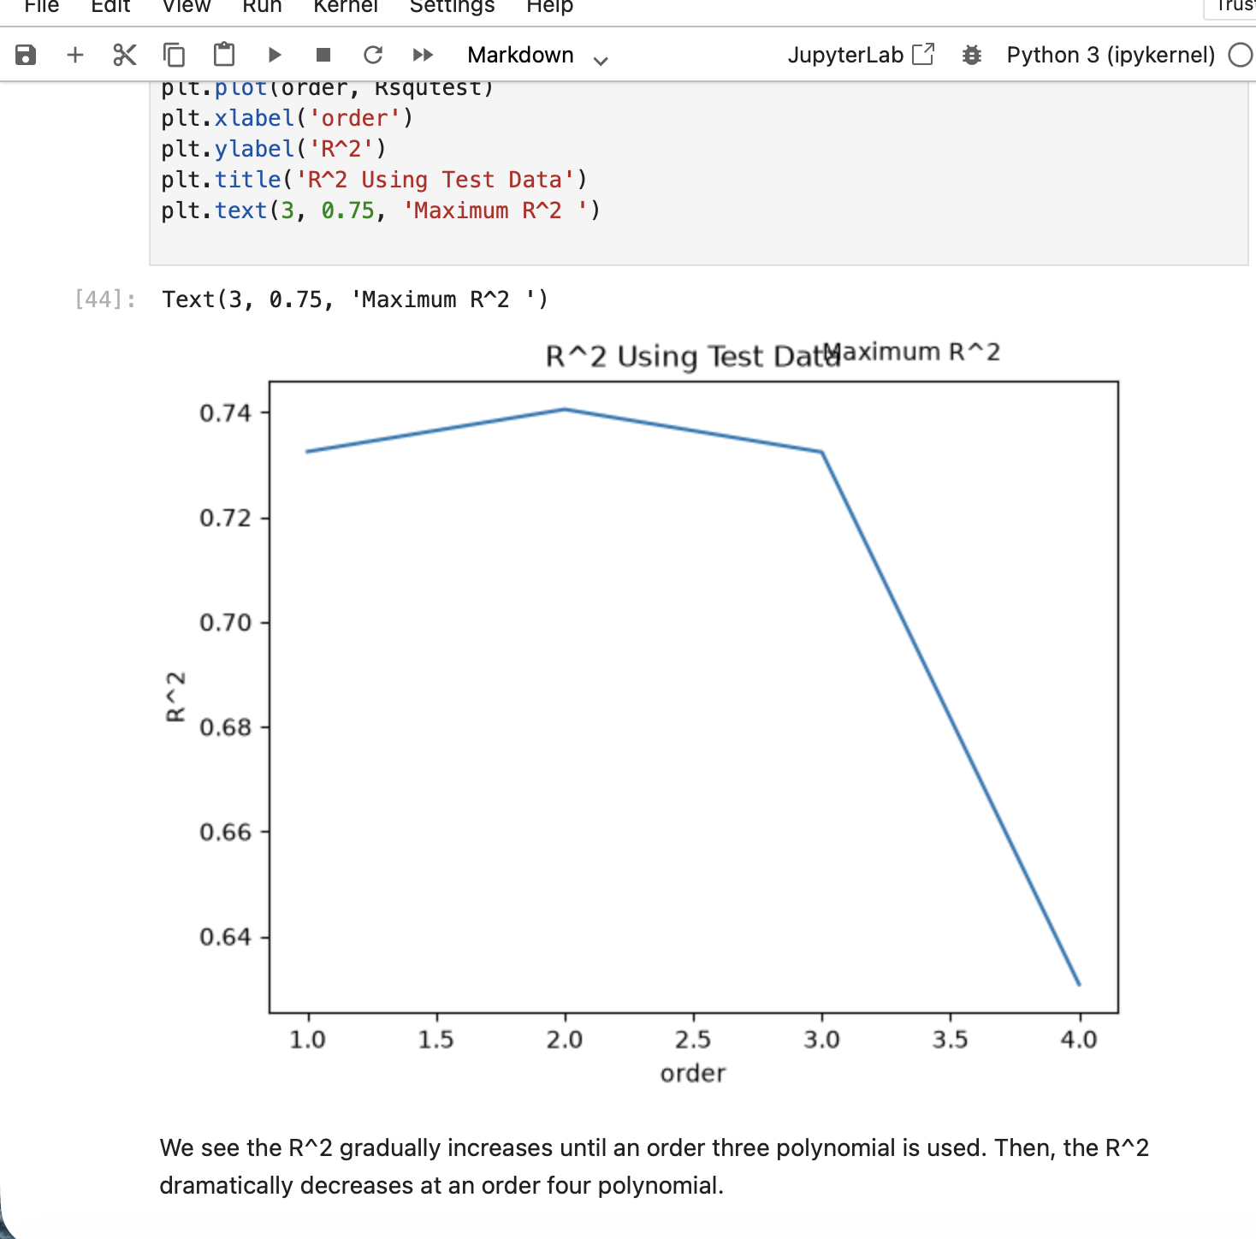
Screenshot file: 16_plot_r2_order.png
The curve rises until the third order and then falls away, which is how the notebook identifies the useful model complexity.

Lab1_17. Question 4 a) PolynomialFeatures of degree two
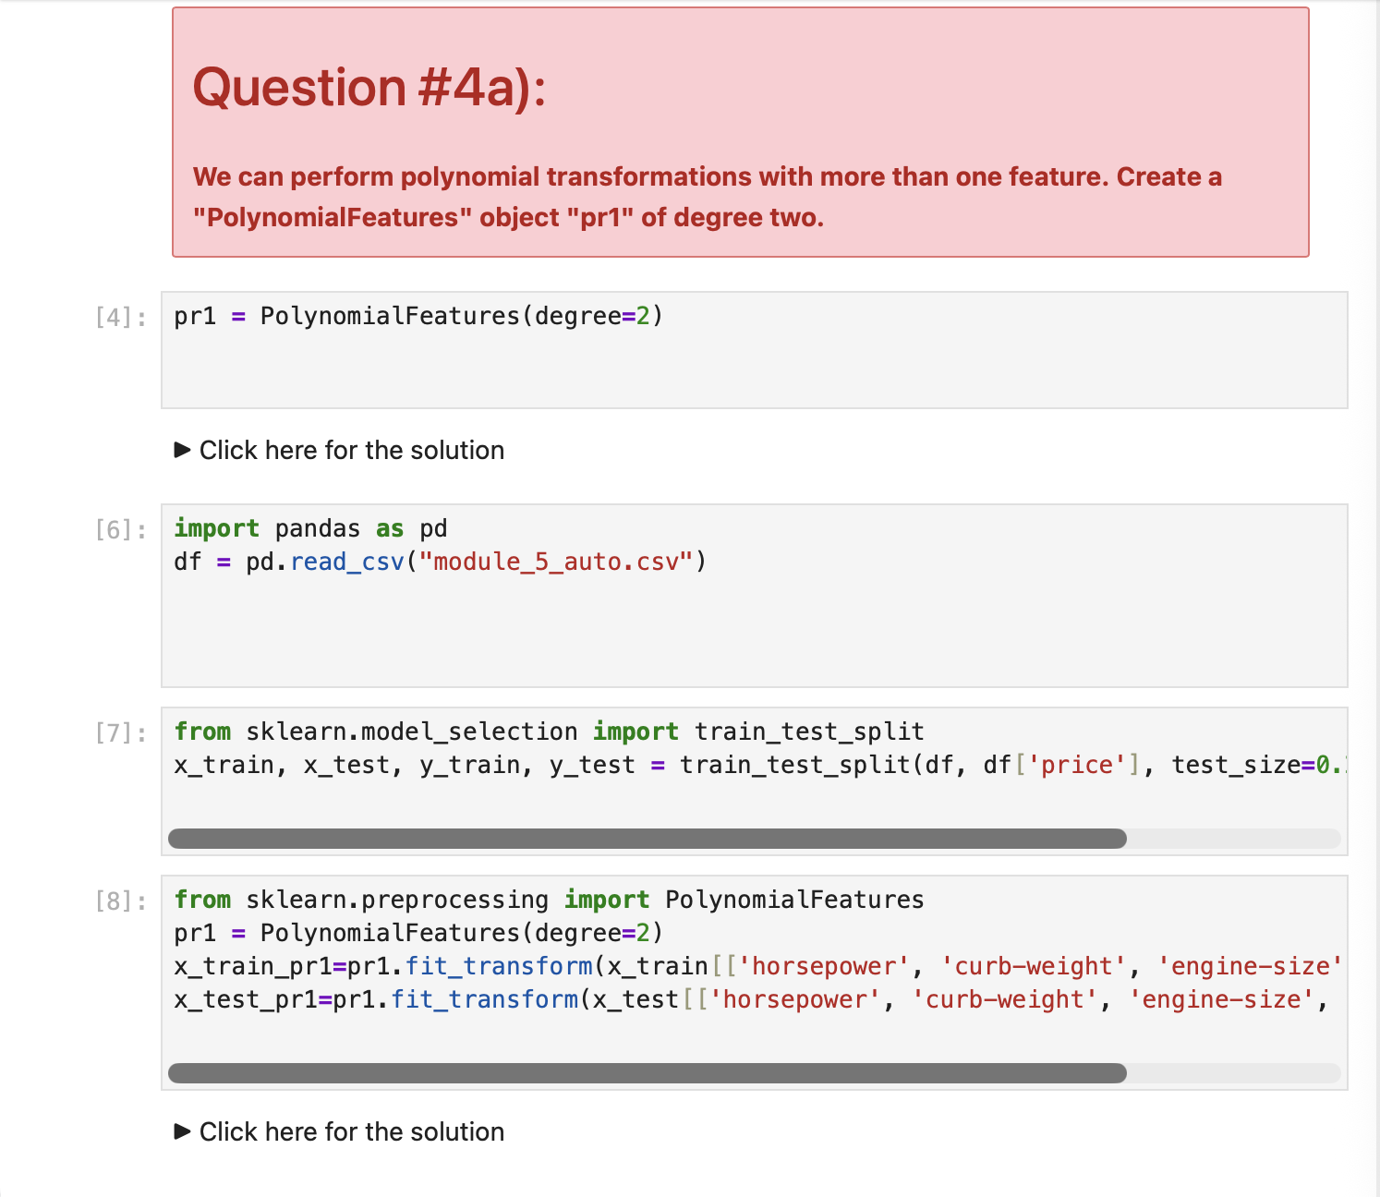
Screenshot file: 17_question4a_poly2_multi_feature.png
pr1 = PolynomialFeatures(degree=2) creates the transformation object requested by the question, which will expand the two features.

Lab1_18. Question 4 c) Dimensions of the new feature set
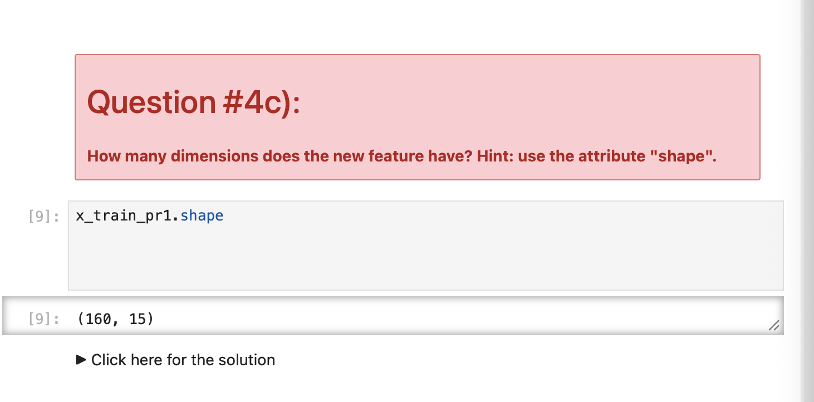
Screenshot file: 18_question4c_shape_dimension.png
The shape attribute of the transformed data is inspected to count how many dimensions the polynomial expansion produces.

Lab1_19. Question 4 d) Creating and training the model poly1
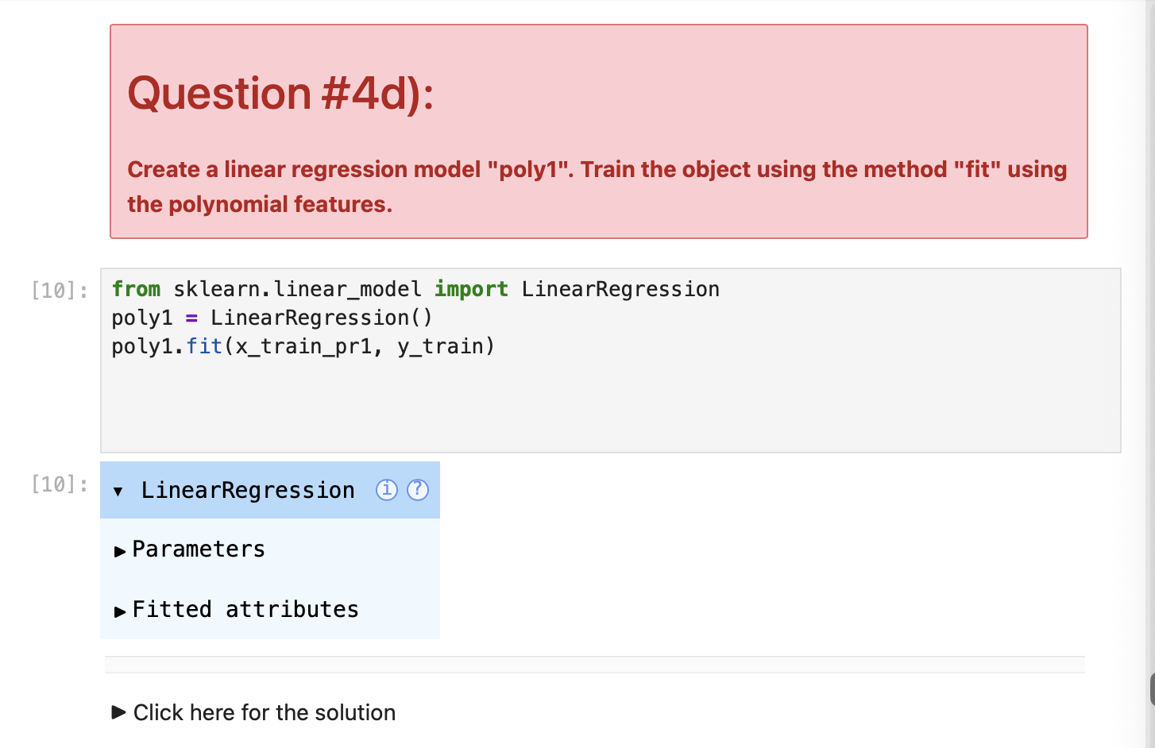
Screenshot file: 19_question4d_poly1_linear_fit.png
The linear regression object poly1 is created and fitted on the polynomial features, as the question asks.

Lab1_20. Question 4 e) Predicting and plotting the distribution
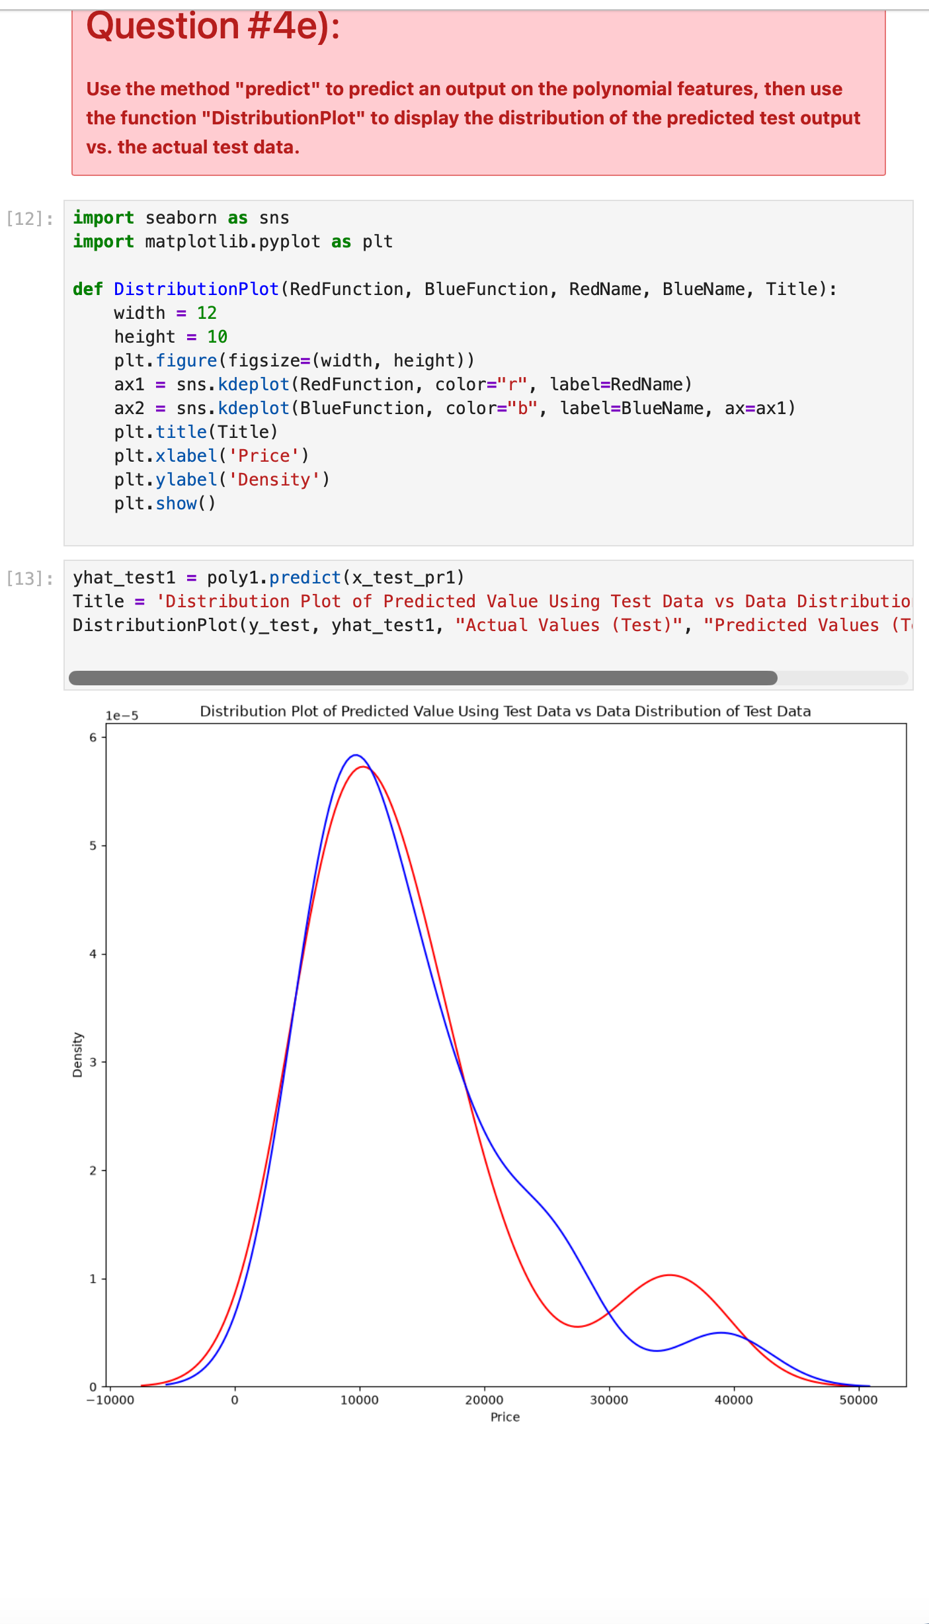
Screenshot file: 20_question4e_distribution_plot_predict.png
The model predicts on the polynomial features and the distribution plot compares the predictions with the actual prices.

Lab1_21. Question 4 f) Reading the two regions of the distribution
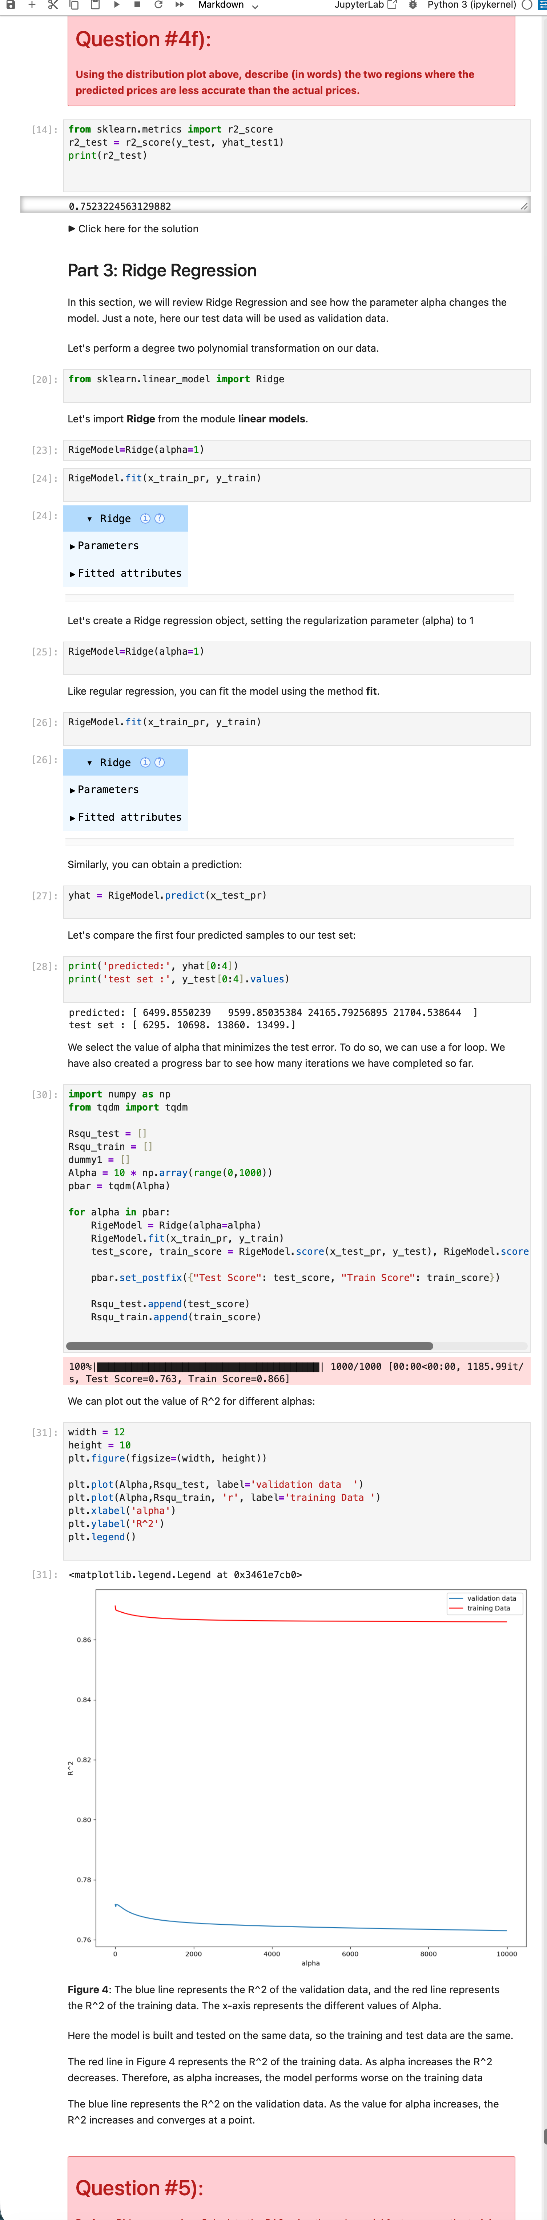
Screenshot file: 21_question4f_ridge_regression_alpha_plot.png
The plot is used to describe the low price region, where the prediction understates the actual values, and the high price region, where it overstates them.

Lab1_22. Question 5 Ridge regression with alpha 0.1
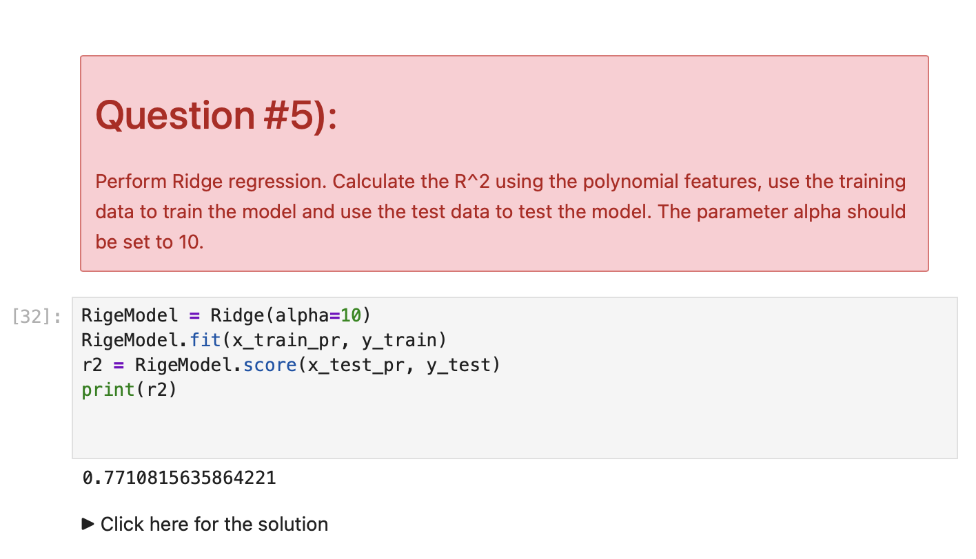
Screenshot file: 22_question5_ridge_alpha10_r2.png
Ridge with the requested regularisation strength is fitted on the polynomial features and the R squared is reported for the training and test data.

Lab1_23. Part 4 Preparing the grid search
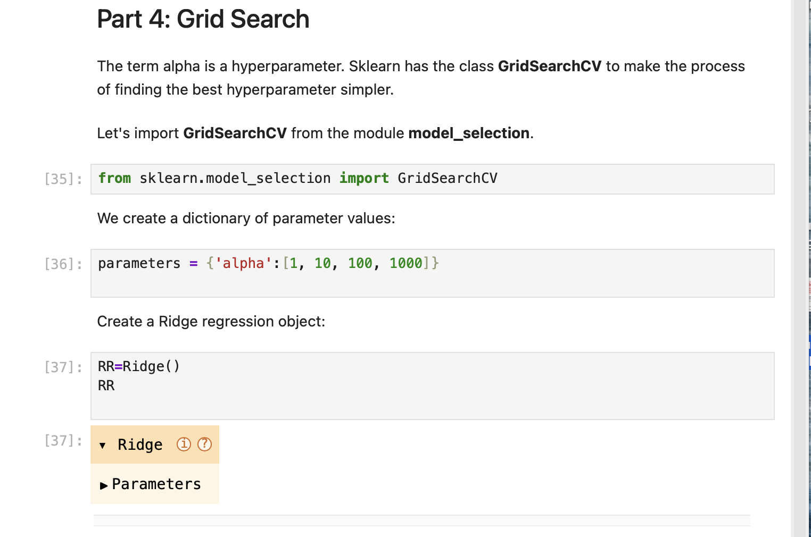
Screenshot file: 23_part4_gridsearch_import_params_ridge.png
GridSearchCV is imported and the parameter grid for alpha is set up, which is the systematic way of choosing the regularisation strength.

Lab1_24. Part 4 Creating and fitting the GridSearchCV object
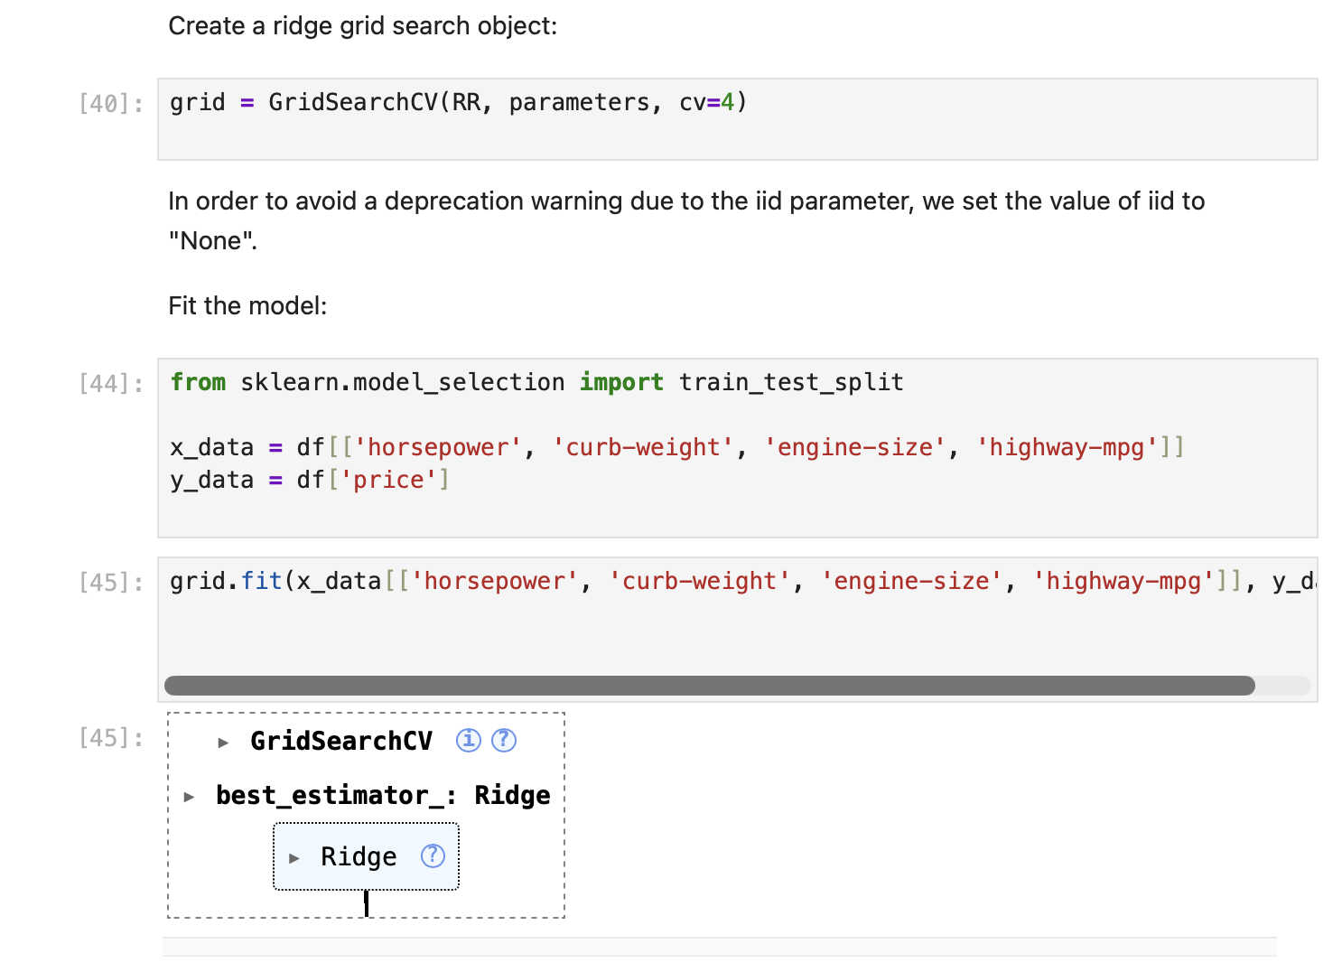
Screenshot file: 24_gridsearchcv_create_object_fit.png
The search object is created with four folds and fitted, which trains a model for every value of alpha in the grid.

Lab1_25. Part 4 Best estimator and its score
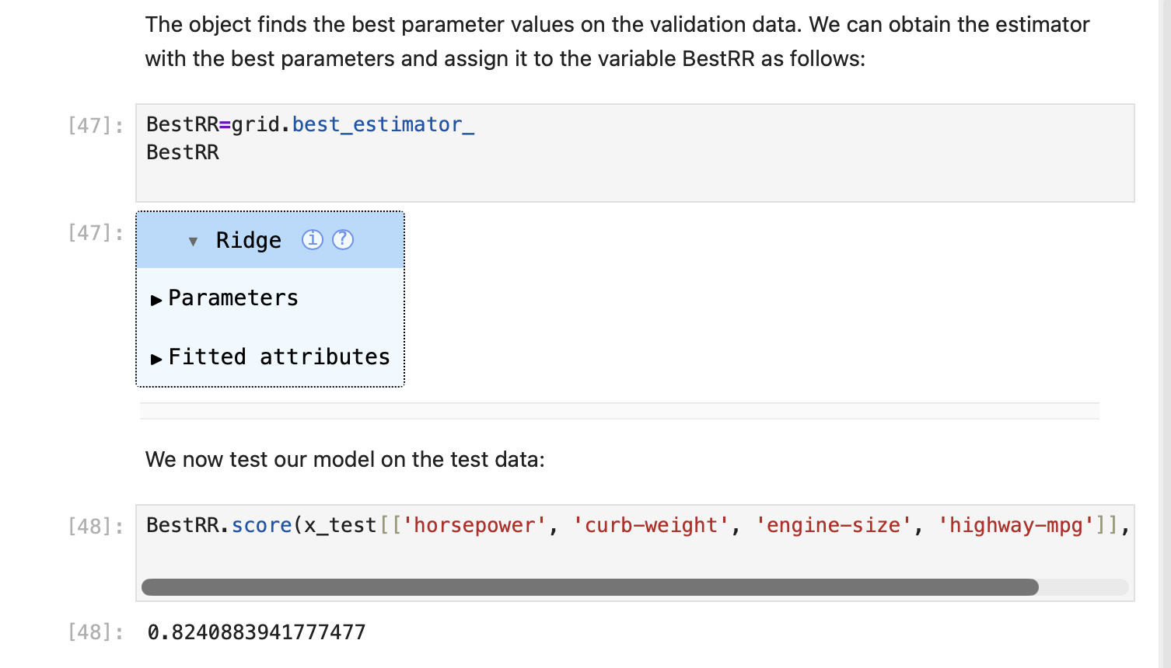
Screenshot file: 25_gridsearch_best_estimator_score.png
The estimator with the best parameters is extracted and scored, which shows how much the tuned model gains over the default value.

Lab1_26. Question 6 Grid search over alpha and the normalisation flag
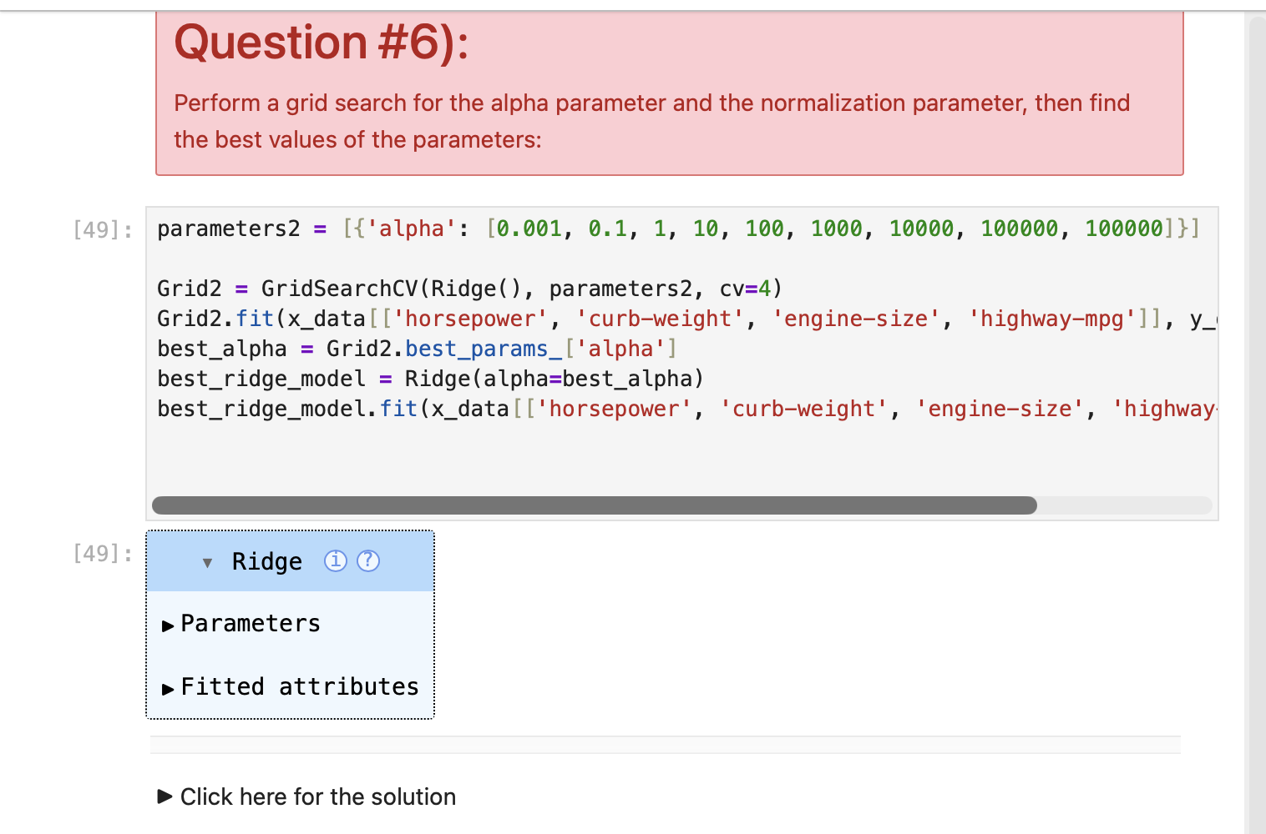
Screenshot file: 26_question6_gridsearch_alpha_normalization.png
The answer searches over both the alpha values and normalize, then reports the best combination and its test R squared.

